Online Appendix C
In figures C1.a, C1.b, and C1.c, we present the marginal effect of oil rent on economic growth in terms of exports for full sample period, and subsample periods 1980-1994 and 1995-2017 respectively.
Figure C1.a: Marginal effect of oil rent on economic growth (1980-2017)
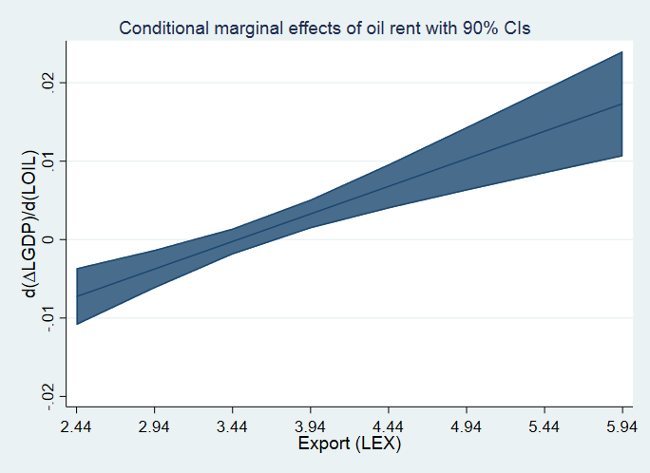
Figure C1.b: Sample period 1980-1994 Figure C1.c: Sample period 1995-2017
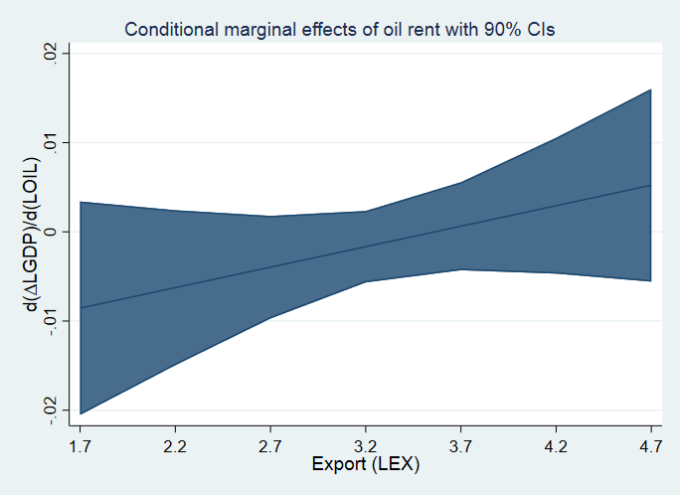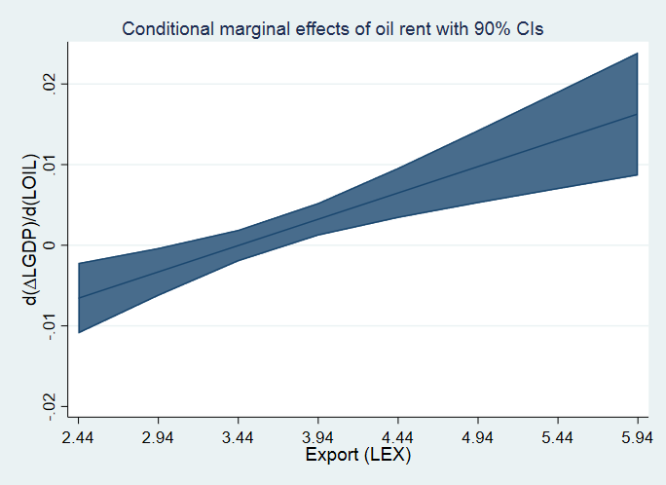

In figures C2.a, C2.b, and C2.c, we present the marginal effect of oil rent on economic growth in terms of imports for full sample period, and subsample periods 1980-1994 and 1995-2017 respectively.
Figure C2.a: Marginal effect of oil rent on economic growth (1980-2017)
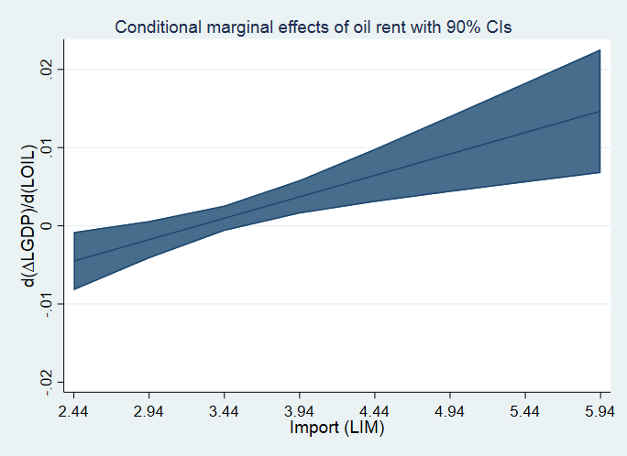
Figure C2.b: Sample period 1980-1994 Figure C2.c: Sample period 1995-2017
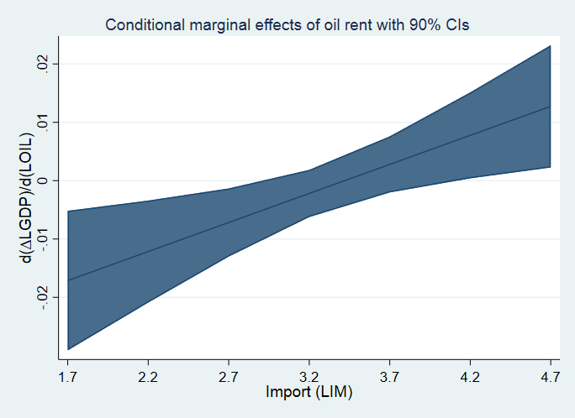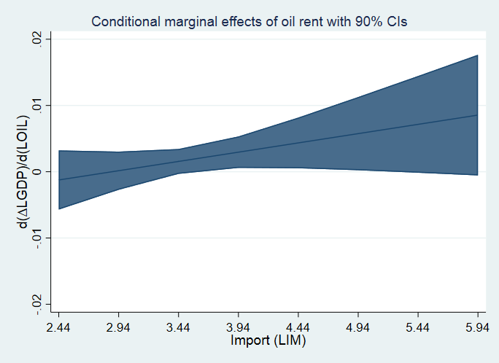

In figures C3.a, C3.b, and C3.c, we present the marginal effect of natural resource rent on economic growth in terms of trade openness for full sample period, and subsample periods 1980-1994 and 1995-2017 respectively.
Figure C3.a: Marginal effect of natural resource rent on economic growth (1980-2017)
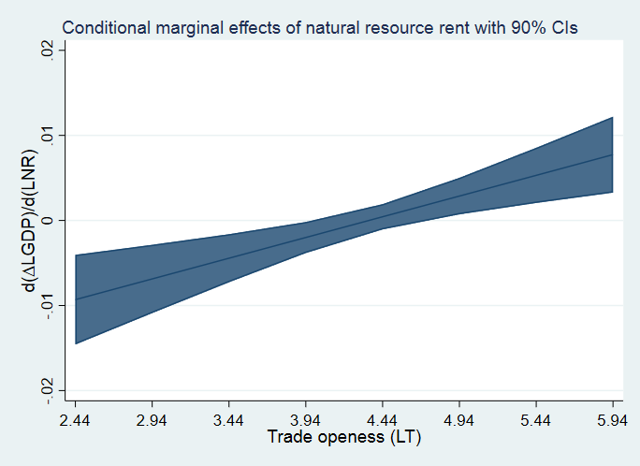
Figure C3.b: Sample period 1980-1994 Figure C3.c: Sample period 1995-2017
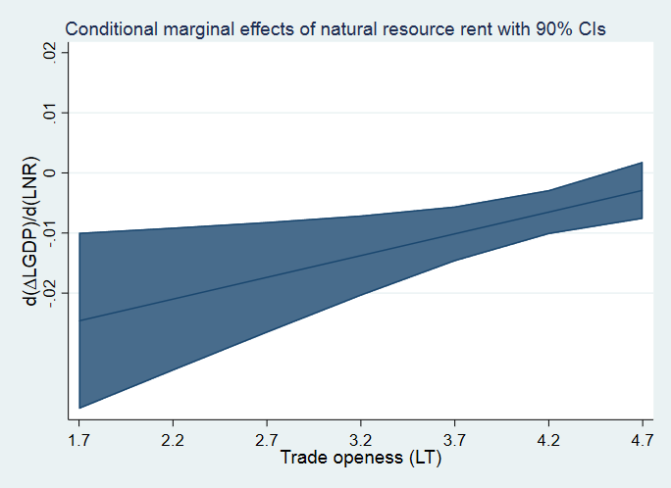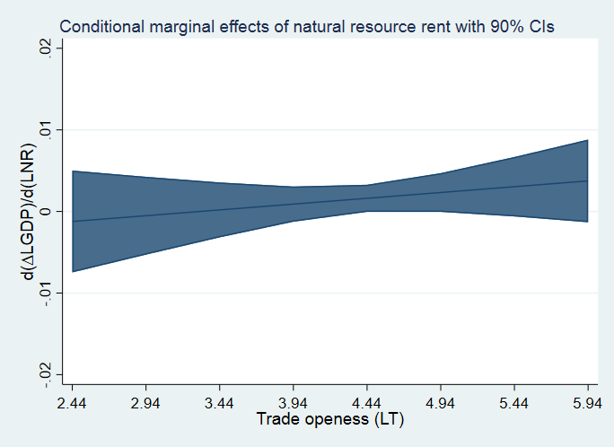

In figures C4.a, C4.b, and C4.c, we present the marginal effect of natural resource rent on economic growth in terms of exports for full sample period, and subsample periods 1980-1994 and 1995-2017 respectively.
Figure C4.a: Marginal effect of natural resource rent on economic growth (1980-2017)
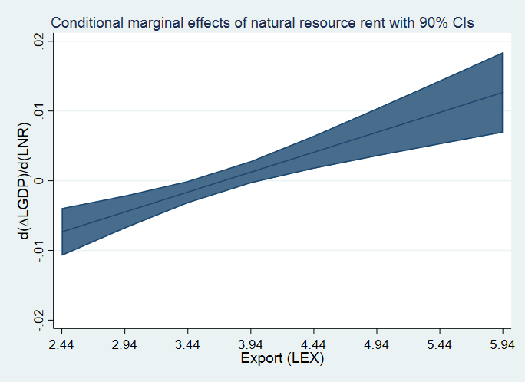
Figure C4.b: Sample period 1980-1994 Figure C4.c: Sample period 1995-2017
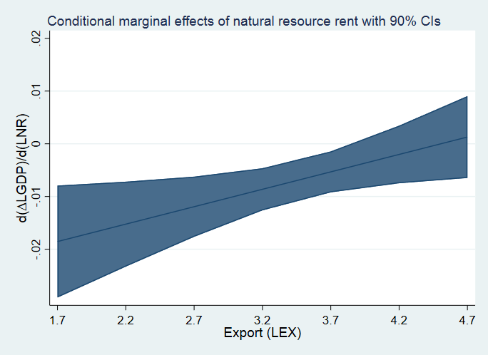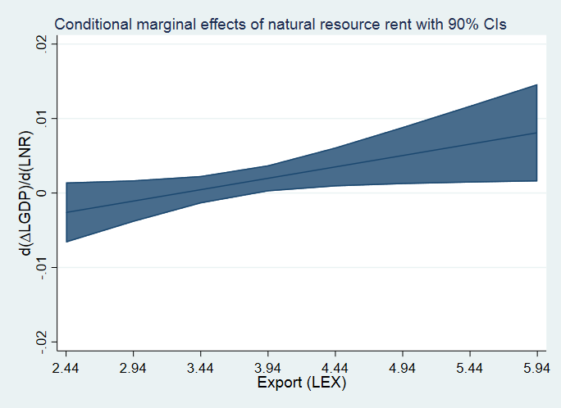

In figures C5.a, C5.b, and C5.c, we present the marginal effect of natural resource rent on economic growth in terms of imports for full sample period, and subsample periods 1980-1994 and 1995-2017 respectively.
Figure C5.a: Marginal effect of natural resource rent on economic growth (1980-2017)
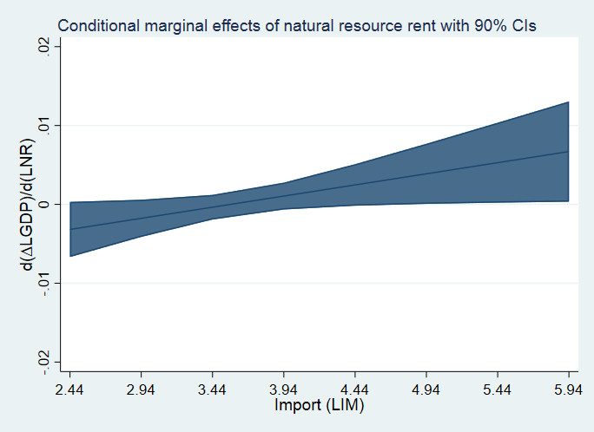
Figure C5.b: Sample period 1980-1994 Figure C5.c: Sample period 1995-2017 